

User Guide

Word for PCs
For ease of navigation we suggest you turn on the Navigation Pane located under the View tab in the menu bar.
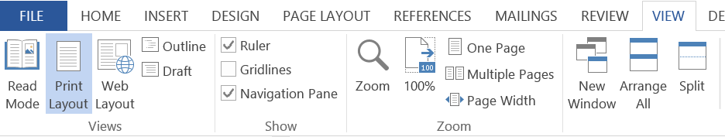

Word for Mac
For ease of navigation we suggest you turn on the Document Map Pane located under the View tab in the menu bar. Select the View tab, select Sidebar then Document Map pane.

This will open up a clickable Navigation column on the left hand side of the document.

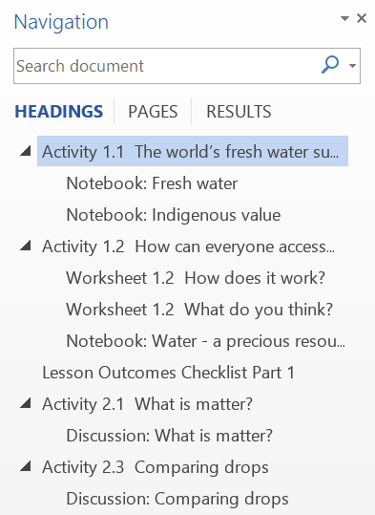

You can select the various elements of each Activity and move through the document with greater ease.

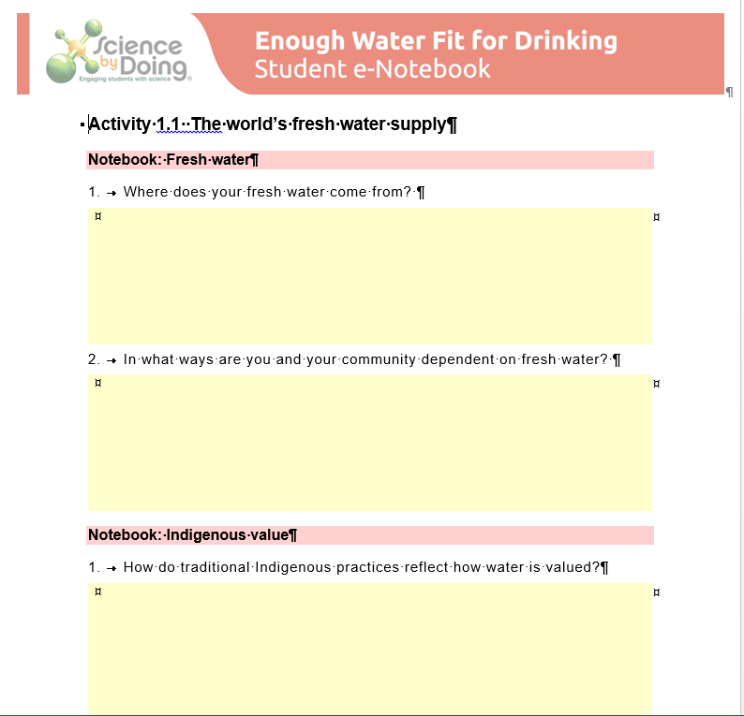

Activity 1.1 Every rock tells a story

Notebook: Rock histories
Write a brief account of how each rock formed.
Sammy Sandstone <Please add image of each rock beside name.>
Betty Basalt <Please add image of each rock beside name.>
Neville Gneiss <Please add image of each rock beside name.>
Connie Conglomerate <Please add image of each rock beside name.>

Activity 1.2 The deep Earth

Notebook: Stiff-toffee-like or runny liquid?
How could the rocks in the mantle be nearly solid (although a bit soft) but flow like a liquid when they come out onto the surface?

Activity 1.3 Cycling rocks

Notebook: Big changes on a long scale
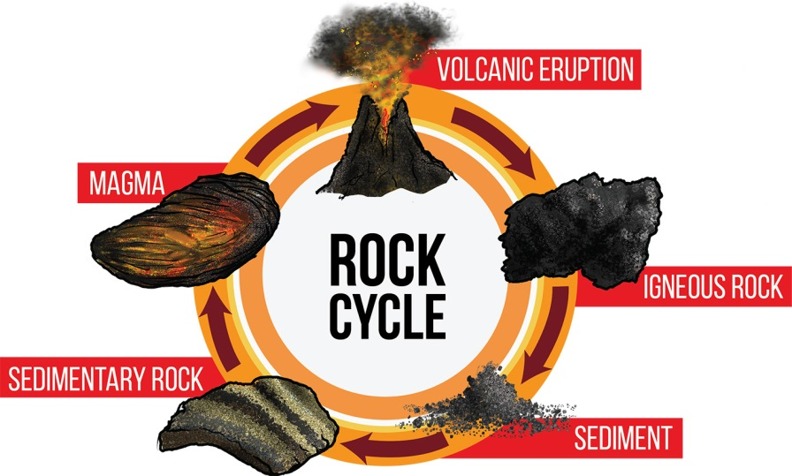
1. Which parts of the rock cycle might happen quite quickly?
2. Which parts of the rock cycle can produce new mountains, and which parts cause mountains to wear away.
3. Australia does not have any big mountains. What part of the rock cycle has been happening most in Australia?

Activity 1.4 It’s all in the crust

Describing rocks
Step 2 - In your Notebook write a brief description of each rock.

Notebook: The three rock types
Now that you have studied rock specimens and explored the online collection Rocks and Minerals, write a brief description of igneous, sedimentary, and metamorphic rocks. Explain how the features of rocks relate to the way they are formed? You could include diagrams or photos as well.
Igneous rocks
Sedimentary rocks
Metamorphic rocks

Lesson Outcomes Checklist Part 1
NAME:
ACTIVITY | LESSON OUTCOMES  At the end of these activities I can: | Please indicate if you achieved each learning outcome:  = Yes  ? = Partly  X = No
1.1 Every rock tells a story | - describe some different rock types
 | - identify that different rocks form under different conditions and have different histories
1.2 The deep Earth | - describe that conditions deep within the Earth are hotter and experience higher pressures than at the surface
1.3 Cycling rocks | - describe simple processes involved in the rock cycle
 | - explain that rocks are formed and broken down continually
1.4 It’s all in the crust | - describe key features of sedimentary, igneous and metamorphic rocks
 | - apply key characteristics to identify some rock samples
 | - explain how the characteristics of different rock types relate to the manner in which they were formed

Activity 2.1 Rock or mineral?

Comparing rocks and minerals
Step 1 - Run your finger over the surface of the sandstone. What does it feel like?
Step 2 - Look at the two rock samples (granite and sandstone) under the microscope. When you look closely at these rocks, what do you notice about their structure?
Step 3 - Look at the mineral sample (calcite) under the microscope. How does it compare to the rock samples?

Notebook: What’s the difference?
1. What minerals were found in each of the rocks?
Granite
Sandstone
Marble
2. What is the difference between a rock and a mineral?

3. What are some of the features of rocks and minerals that can be used to tell them apart?

Activity 2.2 Diagnostic properties

Diagnostic properties
Clever marketing
If you already know which brand of cereal you are looking for, how do you locate it on the shelf?
Step 1 - What diagnostic properties of minerals could we use to tell them apart? Record at least five of these.
Step 2
Diagnostic properties of minerals
Mineral | Colour
Quartz | White
Potassium feldspar
Muscovite
Biotite
Calcite
Hornblende

Discussion:
How would you explain the term "diagnostic property" to one of your friends?

Activity 2.3 Testing minerals

Testing quartz and biotite
Step 2 - Conduct diagnostic tests on biotite and quartz and record your results in the table.
Mineral | Hardness 1 - 10 | Cleavage | Streak | Colour | Lustre
 | Mineral hardness is described on the Mohs scale, ranging from 1 to 10. | Does it split in particular ways, revealing the shape of its crystals? | What colour is its powder if it is scratched on a rough, hard surface? | What colour/ colours is it? | How does it shine in the light?
Quartz
Biotite
Step 3 - Check your results against the table in Activity sheet 2.3. How did your results compare?

Activity 2.4 Rock identification

Notebook: What rock is that?
1. Which minerals are found in rocks A, B and C?
Rock A
Rock B
Rock C

2. Use the table below to identify rocks A, B and C from their mineral composition.
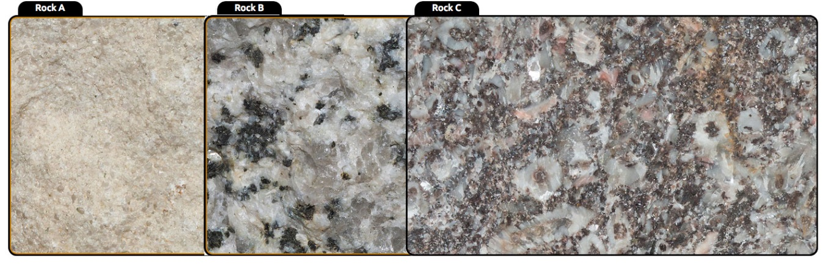

Rocks | Mineral makeup
Andesite | Plagioclase feldspar, augite, hornblende
Slate | Quartz, biotite, muscovite, chlorite
Diorite | Biotite, plagioclase feldspar, hornblende
Limestone | Mostly calcite
Granodiorite | Quartz, biotite, potassium feldspar, plagioclase feldspar
Sandstone | Mainly quartz sand grains held together in a silica cement
Rock A
Rock B
Rock C

3. When granodiorite breaks down into mineral grains, the grains that survive the longest are made of quartz. Why do you think quartz grains survive much longer?

Activity 2.5 Mining our everyday minerals

Notebook: Mining exports
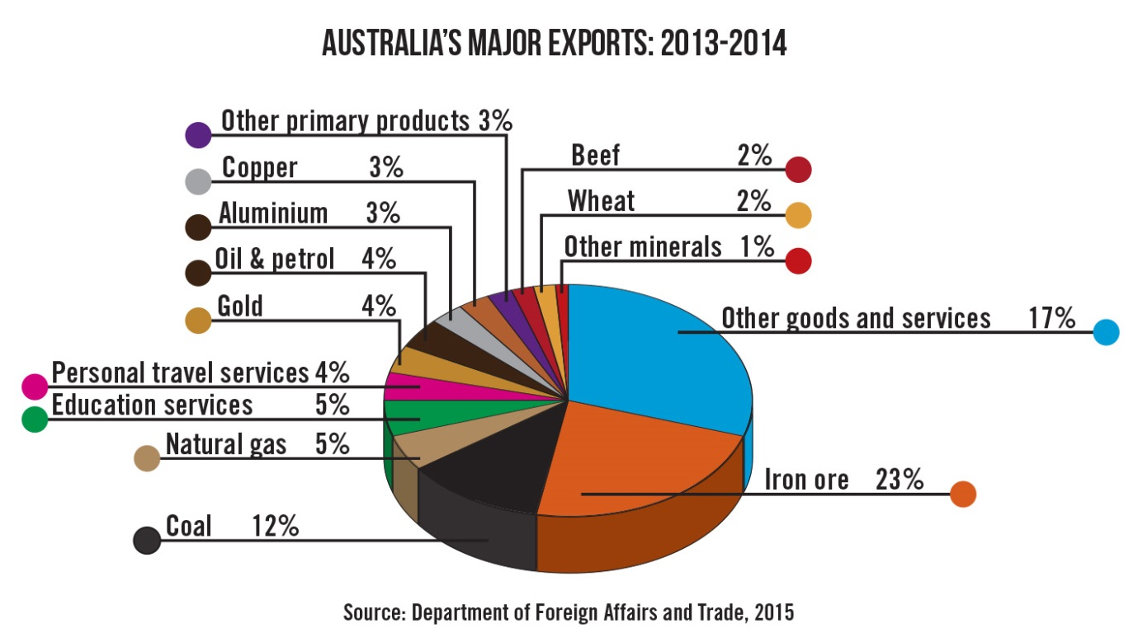

1. What percentage of Australia’s exports are minerals and fuels extracted from the Earth?
2. What are three important exports not coming from the minerals sector?

3. What do you think might be included in ‘Other Goods and Services’?

4. Do you think that Australia is having a problem with any of its major exports today?

Activity 2.6 Careers in mineral exploration

Notebook: Mineral exploration
1. Which person involved in the mining industry do you think has the most interesting job? Explain your answer.
2. In the interactive, what mineral and energy deposits lay under the landscape?
3. Record the correct sequence of steps in mineral exploration shown in the interactive.

Find out more: Where are the mines?
4. After exploring the coal and iron mines in the Australian Mines Atlas in the Find out more section, answer these questions:
a. Where are our important coal and iron mines located?
b. Often, building a new coal mine is more controversial than building a new iron ore mine. Why do you think this is?

Lesson Outcomes Checklist Part 2
NAME:
ACTIVITY | LESSON OUTCOMES  At the end of these activities I can: | Please indicate if you achieved each learning outcome:  = Yes  ? = Partly  X = No
2.1 Rock or mineral | - explain the difference between rocks and minerals
2.2 Diagnostic properties | - differentiate between objects on the basis of their diagnostic properties, using examples from everyday life
 | - explain some diagnostic properties that can be used to identify different minerals
 | - apply diagnostic properties to identify a limited range of minerals
2.3 Testing minerals | - recognise that the characterisation of minerals is a process that allows differentiation between minerals on the basis of their diagnostic properties
 | - explain a number of mineral diagnostic properties such as: hardness, cleavage, streak, colour and lustre
2.4 Rock identification | - recognise that a rock can be identified by characterising the minerals it contains
 | - apply their understanding of mineral characteristics to identify some key rock types

ACTIVITY | LESSON OUTCOMES  At the end of these activities I can: | Please indicate if you achieved each learning outcome:  = Yes  ? = Partly  X = No
2.5 Mining our everyday minerals | - describe a range of products that are made from minerals
 | - match some minerals with their uses
 | - appreciate the value of minerals and fossil fuels to the Australian economy
2.6 Careers in mineral exploration | - describe some of the processes and steps involved in the discovery and mining of valuable mineral deposits
 | - describe some careers involved in the discovery and mining of minerals
2.7 Money for rocks | - identify some minerals that are most important for Australian exports

Activity 3.1 Big and small crystals

Comparing crystal size
Step 5 - Record your observations:-

Discussion:
1. Was there a difference in the growth and final size of the crystals on the two slides?
2. How does this experiment model the formation of crystals in igneous rocks?

3. Could you design an experiment to produce even bigger or smaller crystals?

Activity 3.2 Erupting and intruding

Comparing intrusive and extrusive rocks
Observe the samples of igneous rock provided by your teacher. Examine the rocks with a hand lens or dissecting microscope. What differences do you observe between the granite and basalt samples?

Notebook: Erupting and intruding
Australia has many more landscapes that contain granite boulders rather than basalt flows. Granite type rocks form deep beneath the surface of the Earth, while basalts flow out and solidify on the surface.
1. How do the granites get to the surface?
2. What does this say about Australia’s geology? Are new igneous rocks being formed in Australia today?

Lesson Outcomes Checklist Part 3
NAME:
ACTIVITY | LESSON OUTCOMES  At the end of these activities I can: | Please indicate if you achieved each learning outcome:  = Yes  ? = Partly  X = No
3.1 Big and small crystals | - identify that crystal growth is affected by temperature.
3.2 Erupting and intruding | - identify two different types of igneous rock (basalt and granite)
 | - explain how igneous rocks are formed
 | - explain the link between crystal size and formation of igneous rocks

Activity 4.1 Breaking rocks

Part 1: Physical weathering
Weigh 5 sugar cubes and record the mass in the table. Take a photo or draw a simple sketch of the cubes showing their overall shape and appearance.
Place the cubes in the jar and shake 20 times. Then weigh the whole cubes again.
Repeat this step four more times. Record the weights of the remaining whole cubes and a photo or sketch each time in your data table.
Shaking trial | Drawing/photo of 5 cubes | Mass of 5 cubes (g)
0 shakes
20 shakes
40 shakes
60 shakes
80 shakes
100 shakes

Discussion:
1. What changes did you observe in the cubes?
2. How were the changes affected by the number of shakes?

3. Look up the word abrasion and explain how it is relevant to this experiment.

Part 2: Chemical weathering
Using only 4 sugar cubes design an experiment to test the difference in how quickly the cubes dissolve in water when:
a. The surface area of the sugar is increased by crushing.
b. The temperature of the water is increased.

Discussion:
Chemical weathering occurs mostly through the action of water. Sometimes the water contains small amounts of dissolved chemicals such as carbon dioxide. Record how the chemical weathering (dissolving) of the sugar cubes was affected by surface area and temperature.

Notebook: Weathering and erosion
1. Make a note of the difference between weathering and erosion.

2. Why are these processes important to life?

Activity 4.2 Which sediments where?
Here is a list of the most common sediments and the type of sedimentary rock each makes. Describe a place as near as possible to where you live where you might find each sediment, and how they might have got there. Discuss this with the rest of your class. In some cases this might be quite far away.

Sediment | Location of sediment | How did sediment get there? | Rock type they might eventually make
Gravel and pebbles |  |  | Conglomerate
Sand |  |  | Sandstone
Mud |  |  | Mudstone
Broken down corals and shells |  |  | Limestone
Salt |  |  | Rock salt or halite

Activity 4.3 Sticking things together

Making sedimentary rocks
Part 1
Your task is to design an experiment to determine which binding material produces the most durable rock.
Part 2
Design a test that you could use to compare the hardness of your different rocks. Use this test to determine which binder produces the most durable rocks. Record your results.

Discussion:
Compare your results with other groups in the class and write a conclusion for your experiment.

Activity 4.4 Grains and rocks

Characterising sedimentary rocks
Examine each specimen using the hand lens and the dissecting microscope. Use the descriptions provided in the table below to help you complete your observations table for each specimen.
Clast characteristics
Composition | What are the clasts (grains) made of?
Grain size | How big are the clasts (grains) in the rock?
Sorting | Are the clasts all the same size or different sizes?
Rounding | Are the clasts smooth or rough?
Sphericity | Do the clasts have blocky, flat or elongated shapes?
Observations table
Sediment or rock | Composition | Grain size | Sorting | Rounding | Sphericity
Beach sand
Sandstone
Mud or silt
Mudstone
Conglomerate

Discussion:
Look at the clasts making up each of the three rocks. Can you determine which sedimentary environment produced each rock?
Rock | Sedimentary environment
Mudstone
Sandstone
Conglomerate

Notebook: Sammy Sandstone
1. What sort of sediment is Sammy made from? How did it accumulate in one place?

2. How did the sediment turn into Sammy Sandstone?
3. Sandstone is a very useful stone. Research what sorts of things rocks like Sammy are used for.
4. What characteristics would you use to identify a rock like Sammy (i.e. a sandstone)?

Activity 4.5 Making rocks from body parts

Activity 1: Testing for calcium carbonate.
Step 1 - Test each sample you have with a few drops of HCl. Record your observations in your Notebook.
Step 2 - Now observe the piece of limestone under the microscope. Can you observe individual grains?

Discussion:
All the samples that fizzed contained calcium carbonate. Which samples did not?

Activity 2: Burning coal
Step 1 - Examine the piece of coal under the microscope. Describe its appearance.
Step 2 - Crush a small quantity into the crucible and heat with the Bunsen. Observe its reaction.

Notebook: Biogenic rocks
In your Notebook describe two different rocks that are made from body parts. These are called biogenic rocks.
One of these rocks is very important to Australia’s economy.
a. Which rock is it?

b. Why is this rock now very controversial?

Lesson Outcomes Checklist Part 4
NAME:
ACTIVITY | LESSON OUTCOMES  At the end of these activities I can: | Please indicate if you achieved each learning outcome:  = Yes  ? = Partly  X = No
4.1 Breaking rocks | - explain how rocks can be broken down through the processes of physical and chemical weathering
 | - explain the effects of surface area and temperature on chemical weathering
 | - distinguish between the processes of weathering and erosion
4.2 Which sediments where? | - relate the formation of different sediments to different landscapes
 | - relate different sediments to the formation of different sedimentary rocks
4.3 Sticking things together | - explain how sediments can form into rocks in the presence of suitable binders
 | - design a method for testing and comparing the hardness of hand-made rocks
4.4 Grains and rocks | - recognise that different sedimentary rocks can be characterised by the size of their grains
 | - recognise that different sedimentary rocks can be characterised by whether they form from grains or chemical or living sediments
4.5 Making rocks from body parts? | - explain how living material can be incorporated into sediments and transformed into sedimentary rocks
 | - use the acid fizz test to identify limestone and related rocks
 | - describe some current uses of rocks made from living material.

Activity 5.1 These rocks are so hot!
Part 3: Comparing bricks
Design some tests to assess the ‘rockiness’ of your bricks. What characteristics do rocks have? How do they react to water or to pressure. Are they hard or soft?

Discussion:
1. Describe how the properties of your rock changed in response to high heat.
2. How does this relate to the formation of some metamorphic rocks?

Notebook: Contact metamorphism
Contact metamorphism occurs when rocks experience sudden high temperatures when they are exposed to molten magma at fairly shallow depths.
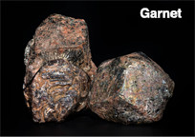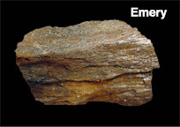
Garnet and emery are two minerals formed through contact metamorphism. They are valuable for different reasons. How are these two minerals used today?

Activity 5.2 Regional metamorphosis
Testing for calcium carbonate

Discussion:
Describe whether marble responded in the same way to the acid test. What can you conclude from this?

Notebook: Metamorphism: Big changes
Write a brief summary describing the difference between limestone and marble. (You could use your observations in class of a piece of limestone and a piece of marble or observe the specimens in the online collection Rocks and Minerals.)

Activity 5.3 A tortured history

Notebook: Metamorphism: putting it all together
1. What sorts of conditions have metamorphic rocks experienced?

2. What sorts of changes do they undergo?
3. Migmatite is a special case. What is special about it?

Lesson Outcomes Checklist Part 5
NAME:
ACTIVITY | LESSON OUTCOMES  At the end of these activities I can: | Please indicate if you achieved each learning outcome:  = Yes  ? = Partly  X = No
5.1 These rocks are so hot! | - explain the role of heat in the formation of contact metamorphic rocks
5.2 Regional metamorphosis | - explain the role of temperature and pressure in the formation of regional metamorphic rocks
 | - identify that metamorphic rocks can have similar chemical compositions to their parent rock
5.3 A tortured history | - provide a summary of the conditions under which metamorphic rocks form and the processes involved
 | - explain that if metamorphic rocks melt then they are becoming magma and are no longer metamorphic rocks

Activity 6.1 Rocks into rocks

Notebook: Your local geology
Research the geology of your local area.
1. What types of rocks are beneath your town and your feet? Are they sedimentary, igneous or metamorphic?

2. What does this tell you about the ancient history of your region?

Find out more: James Hutton: “Mr Rock Cycle”
Write down answers to the following questions based on the understanding you have gained in this unit. You could also research James Hutton and note some of his most important discoveries.
1. Why do some granite formations look like they have flowed or been pushed into other rock formations?

2. Soil is being eroded all the time but we don’t run out. Where does new soil come from?
3. Why do layers of sedimentary rocks look like layers of sediments? How long would it take for rocks to be recycled?

Discussion: Modelling the rock cycle
In this activity you will compare the properties of wax crayon that has been exposed to different conditions.
1. How was weathering and erosion modelled in this activity?
2. Which part of the activity modelled the laying down of sediments, and then the pressure that creates sedimentary rocks?

3. How did the model represent the heat and pressure that creates metamorphic rocks?
4. How was the formation of igneous rocks modelled in this activity?

Activity 6.2 On the level
Activity 1: Making sediments

Discussion:
- Which is the oldest sediment (first deposited) in your bottle?
2. Did each of the sediments settle out evenly in your bottle?
Activity 2: Graded bedding

Discussion:
1. The pattern produced in this experiment was different to the one produced in Activity 1. How was it different?
2. How might a pattern like this one be produced in real life, for example in a shallow sea with a large river flowing into it?

Activity 6.3 How do fossils form?

Notebook: Our fossil past
Naracoorte Fossil Site
The Naracoorte Caves are located halfway between Melbourne and Adelaide.
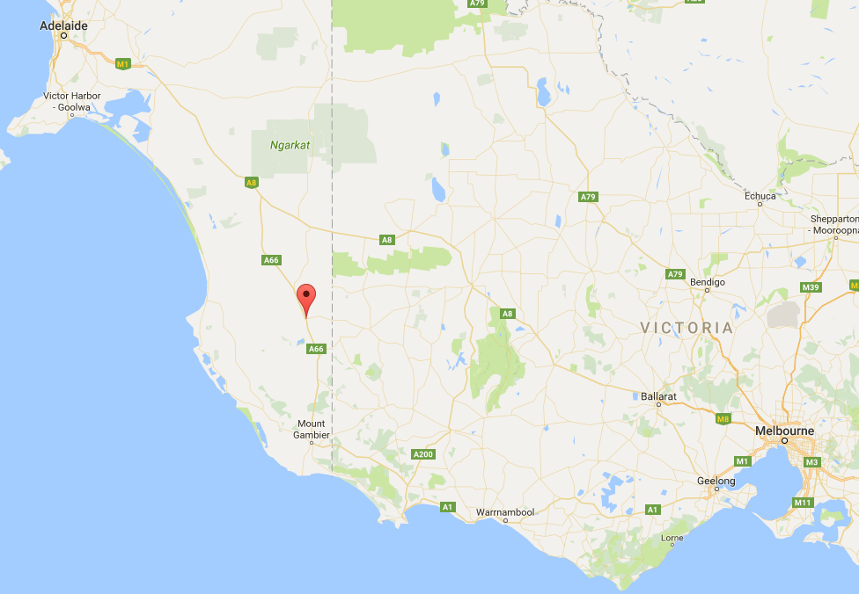
These limestone caves are World Heritage listed, and one of the world’s most important fossil sites. For 500,000 years the caves have acted as pitfall traps. Animals would fall in through a hole in the ground and not be able to escape.

The caves also formed protected environments that preserved their skeletons intact. Year after year, animals kept falling into the holes, getting covered by sediments and creating a rich fossil record of the ancient animals that roamed the area.
A scientist who studies fossils and the forms of life that existed in former geological periods is called a palaeontologist. Today, palaeontologists are digging through the cave sediments to unearth fossilised bones.
Palaeontologists have excavated and dated many of the fossils in Naracoorte Caves. They have reconstructed the skeletons of many of the megafauna that lived so many years ago. Click here to see some of these mega animals.
1. Why did the megafauna grow so big?
2. Why did they die out?

3. Describe three of the megafauna found at the Naracoorte Fossil Site.
NAME | DESCRIPTION
4. What have palaeontologists learnt about the landscape and rocks around us by studying the fossils they contain?

Activity 6.4 Is this the same as that?
Stratigraphy
This activity is similar to the work palaeontologists do as they try to understand the deposition history of sedimentary beds they find in different parts of the world. This is known as Stratigraphic Correlation. Complete the tasks in Activity sheet 6.4 Stratigraphy before answering these questions:-
Task 1 – Letter cards
Copy the sequence of letter cards with the TC card at the bottom of the stack indicating the oldest fossils and the top card representing the youngest fossils of this rock sequence.
1. How do you know that “X” is older than “M”?
2. Explain why “D” in the rock layer represented by DM is the same age as “M.”

3. Explain why “D” in the rock layer represented by the OXD is older than “D” in the rock layer represented by DM.
Task 2 – Fossil cards
4. What problems did you run into when trying to arrange the fossils into the correct sequence?
5. Would this have been more difficult if you did not know which layer was the oldest to start the activity?
Extension
1. Research the different fossils and identify where they are found on the geologic time scale. Does this information match the pattern in this activity?

2. Use this information to postulate possible ages for the different rock strata in this activity.
Note: The rocks represented in this geological stratum are sandstone, limestone, shale and dolomite. Dolomite is a rock similar to limestone.

Activity 6.5 Relative geological time

Notebook: How did the Grand Canyon form?
Write a short summary of the geological history of the Grand Canyon.

Notebook: The Grand Canyon’s Rock Layers
Next to each layer write down the name of the geological period and the names of possible fossils that might be found in that layer. Use the information provided in the Student Guide. You could also research each of the geological periods to find out what sorts of organisms lived at that time and what sorts of fossils might be found.
Layer | Age of layer in millions of years | Period or Era | Fossils
Kaibab limestones | 270
Toroweap shale and sandstone | 273
Coconino sandstone | 275
Hermit formation; siltstone, mudstone, sandstone | 280
Supai group sandstone | 285 - 315
Surprise canyon; sandstone, conglomerate, limestone | 320
Redwall limestone | 340
Temple Butte limestone | 385
Muave limestone | 505
Bright Angel shale | 515
Tapeats sandstone | 525
Grand Canyon Supergroup; mudrock and sandstone | 600 - 1200
Vishnu Basement rocks; granites, schist and gneiss | 1680 - 1840

Most of the rock layers in the Grand Canyon contain fossils. Many of these come from marine environments.
1. From your table, describe how the fossils have changed from the earliest to the latest rocks. How did life on Earth change during this time period?
2. Would you expect to find any of the following fossils in the Grand Canyon deposits?
a. Human fossils
b. Dinosaur fossils
c. Fish fossils
3. Which layer would you expect to contain very few fossils?
[Hint: Look at what type of rock the different layers are made from.]
4. Many of the layers appear to have been laid down in shallow, tropical seas. How do we know this?

Activity 6.6 How long does it take?
Rock Cycle Game
Dice roll | Time (years) | What happened?
1 | 200,000
2 | 400,000
3 | 600,000
4 | 800,000
5 | 1,000,000
6 | 1,200,000
7 | 1,400,000
8 | 1,600,000
9 | 1,800,000
10 | 2,000,000
Step 6
Draw a rock cycle diagram and show the pathway your rock took. Compare your rock’s history with other students in your group.

Discussion:
1. In what ways did the rock histories differ?

2. In which part of the rock cycle did your rock spend the most time?
3. Which part/s of the rock cycle did your rock miss?

Notebook: Natural disasters
Describe some of the ways that an understanding of geology can help us predict and understand some natural disasters.

Activity 6.7 Forming landforms

Notebook: Landform processes
For each of the landforms fill in the table indicating:
- Which process or processes were involved: weathering, erosion or deposition?
- A brief description of what happened. What order may these have happened?
Landform | Processes | Description of what happened
Blue Lake
Uluru
Twelve Apostles

Lesson Outcomes Checklist Part 6
NAME:
ACTIVITY | LESSON OUTCOMES  At the end of these activities I can: | Please indicate if you achieved each learning outcome:  = Yes  ? = Partly  X = No
6.1 Rocks into rocks | - explain the concepts and processes described in each step of a rock cycle diagram
6.2 On the level | - explain how sedimentation events can lead to different patterns in sedimentary rocks
6.3 How do fossils form? | - explain some of the processes and conditions required for the formation of fossils
6.4 Is this the same as that? | - explain how the distribution of fossils in rock strata can be used to provide an indication of their relative ages

Acknowledgements
Science by Doing is supported by the Australian Government Department of Education, Skills and Employment. The views expressed here are those of the author and do not necessarily represent the views of the Australian Government Department of Education, Skills and Employment.
Copyright
© Australian Academy of Science, 2021
Rock your World, Student e-Notebook: ISBN 978-0-85847-803-9
Published by the Australian Academy of Science
GPO Box 783
Canberra ACT 2601
Telephone: 02 6201 9400
www.science.org.au

The details of the relevant licence conditions are available on the Creative Commons website (accessible using the links provided) as is the full legal code for the Creative Commons Attribution-NonCommercial-ShareAlike 4.0 International (CC BY-NC-SA 4.0) licence (https://creativecommons.org/licenses/by-nc-sa/4.0/legalcode).
Click here for a full version of unit acknowledgements and sources or logon to www.sciencebydoing.edu.au.
Last revised: 29 October 2021

